**Professional Practice in IT Project**

**Project Document**

**PcBuilderPro**

**Build a Custom Pc Webpage**

**Created by:**

**Connor Brookfield – G00361129**

**Jack Haugh – G00359747**

Table of Contents

**Professional Practice in IT Project** 1

Introduction 3

System Requirements 5

Technology Used 7

Design Methodology 8

Limitations and bugs 11

Features of Project 12

Testing 16

Recommendations for the future 17

Conclusion 18

References 19

## 

## Introduction

* For our 3rd Year project for Professional practise in IT, Connor and I decided to create a build-a-pc website which had different functions such as Login feature for an admin to add more components to component page, a contact page which the user could submit a query and that query displays on the forum page, and a basket so when user adds the components for their pc it sends to a shopping basket.
* For the Front-end section of the project we decided to use react -bootstrap. React - bootstrap is a front-end stylesheet library which includes the react.js library and bootstrap library but combines the two together when running react – bootstrap. It is built from scratch without the need of dependencies such as jQuery.
* For the Back-end of the project we decided to use MongoDb, Express.js & axios.js. MongoDB is a document database which stores data in JSON-like documents and the document model maps to the objects in your code on your project. Express.js is a minimal and flexible Node.js web application framework that provides features for web and mobile applications. Axios is a popular HTTP client that has an easy-to-use API and can be used in both the browser and Node.js.
* The goals of the project for Connor and I were:
  + Have a completed & functional website with the points we made in first point of this section.
  + Improve our Communication and teamwork skills in a group-based project especially when we had to interact over a online chat application.
  + Learn new methods of coding we haven’t used before while also relearning code taught to us from previous years.
  + Learn more about how databases work and sending information from database to applications

## System Requirements

* To run our Website along with mongoDb Server, the user must
  + Download the repository from github by cloning the project to your pc in a folder of your naming convention.

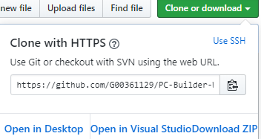

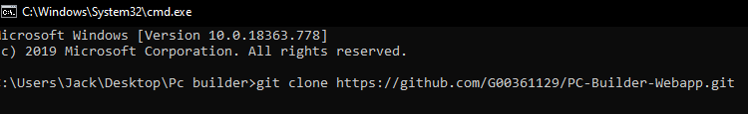

* + Open folder and in command line and run using the command npm start. 
  + To run server open project and on the server.js file open it in terminal and then type node server.js to run the mongo Database to show the different parts of the site and give

functionality to certain pages.

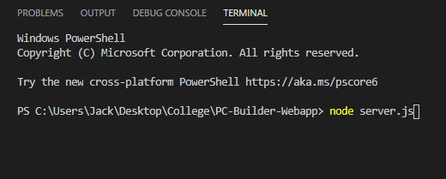

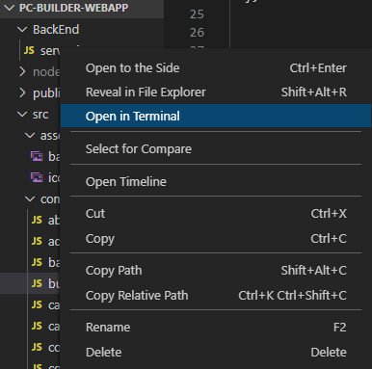

* + Note there might be errors when trying to run on either cmd or server.js where it might ask you to install dependencies such as axios, react, stack, cors and express.
* You will also need a text editor to run and see code properly. E.G. Visual Studio Code is what we used for the project workspace. 

## Technology Used

* The different technology used for this project was:
  + **React-Bootstrap:** We used react-bootstrap for the template of the project as it has excellent UI foundations and gives the user more control over each component of their work.
  + **Node.js:** We used node.js because it helped with communication between application and server to send out the info from it.
  + **Mongo Database:** We used Mongo DB as it is a document-oriented database model which supports different types of data. For this reason, it made it easy to store data in Mongo and send it with commands.
  + **Visual Studio code:** We used Visual studio code for the text editor as it as it has a lot of benefits e.g. Terminal Support which we used to run the server.js class its light-weight when running as it doesn’t have a high chance of freezing or shutting down unexpectedly cause of its low ram usage, and it’s a great addition for web technologies.
  + **Browser:** The user needs a browser such as google chrome or Mozilla Firefox to run the application on the local host.

## Design Methodology

* When first setting out on the ideas of what we were doing for the project we decided on different things.
  + **The end goals:** When creating the project, Connor and I decided that we were creating a web application that allowed the user to pick different pc components that sends to a basket. We also decided on a login feature to let user add more components to the pc parts page. We also wanted to use a database to store info to server to then retrieve it.
  + **Choosing our Database:** We decided that mongo DB was the best option to use for a database for the reasons listed.
    - It was something, we were familiar with using from past years
    - It could be accessed remotely by Connor or myself anytime.
  + **Setting up and flow of project:** Connor setup the workspace and GitHub repository when creating the project originally. After this we then decided on what to do each while also helping on other parts also. Connor created the templates and carousal at first while designed the home, about and contact pages. Connor then created a server page and started on our components for the build pc page and I done the rest with buttons for the add to cart. We never had trouble doing the work and spreading the load and communicated well when pushing the repository to GitHub when we had to pull from it to get our colleagues added work to ours.
  + **Code Quality:** When we done all the work, we had set out to do on the project we then looked at how we could improve the code visually and functionality wise to make it more appealing to the user to use. So, we looked for any code that could help us with changes and deleted unnecessary code that had no use to us. We then added comments to parts of code for people viewing it to see what code done what.
  + 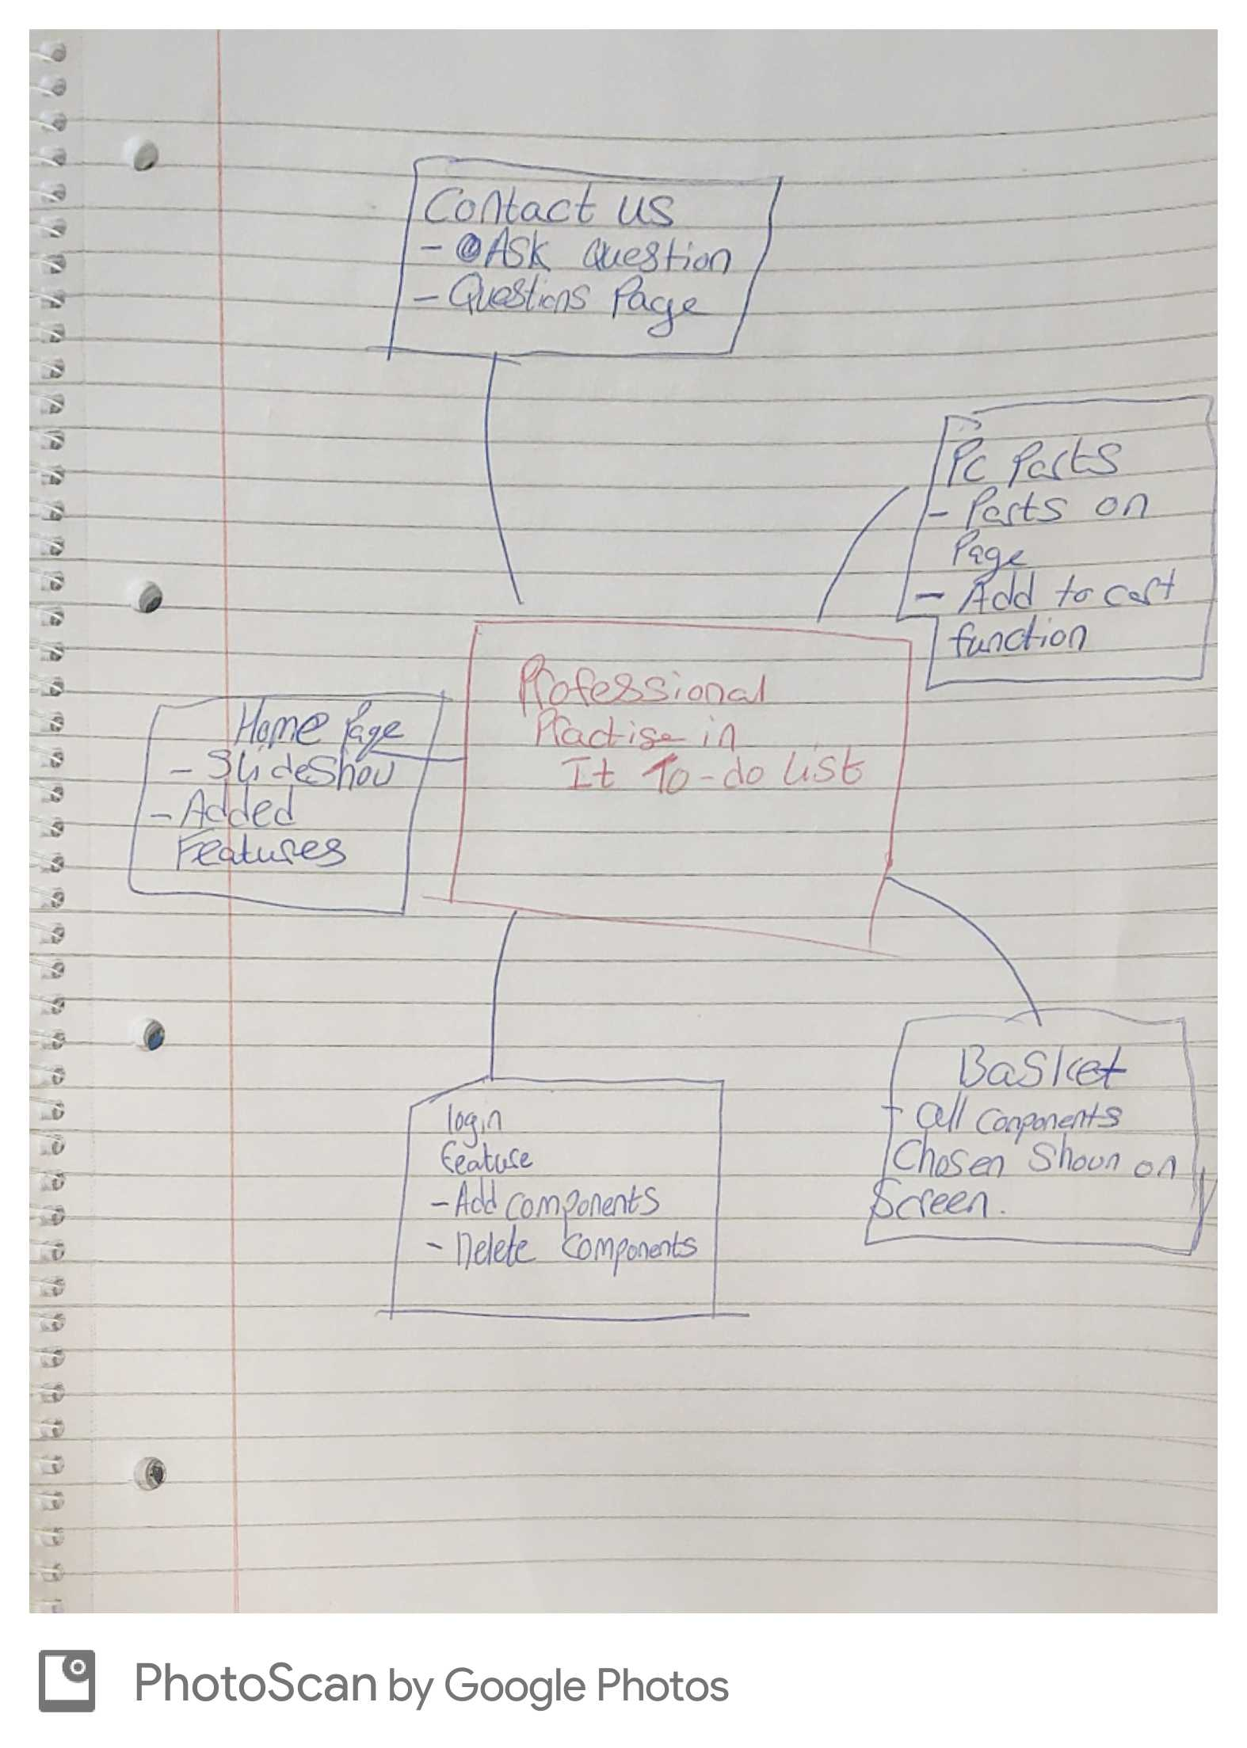

A rough idea of what we set out to do when we were together in college.

## Limitations and bugs

* While doing the project Connor and I hit a few speedbumps along the way involving the code itself and other factors.
  + No face to face meetings: This was a big factor as because of the global pandemic we had to stay indoors and keep away from physical contact. We had to resort to using the internet all times and some days suffered because of bad WIFI speeds and couldn’t contact all times bar nights.
  + Time: Time was a big factor also during this project as before the pandemic we were balancing out projects and college work and during it we had more projects to do on top of this and finding time to get this done got difficult.
  + JavaScript: We found while using JavaScript that it is a weakly typed language because variable types are not declared and become confusing at time.
  + Mongo DB: We found if naming variables in database don’t correspond with the project it won’t output as you wish. Examples we faced was naming storage as storageDevices and didn’t match with the code in our project and changing letters to upper or lower case.

## Features of Project

* Our website has different features that we are happy how it came together
  + Our home page has a navbar which can direct to different parts of the website and has a slideshow which by clicking on the image can direct you to the items website

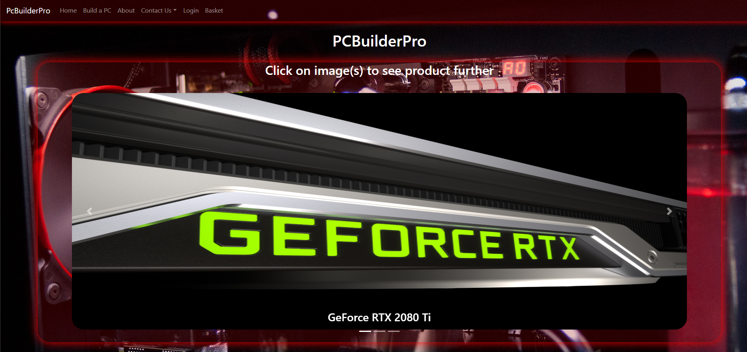

* + Our Build a PC page has different components on it and when the user adds a component to their basket it will tell the user if they didn’t add all components needed then a alert message show what part(s) they need to add to have their shopping basket filled.

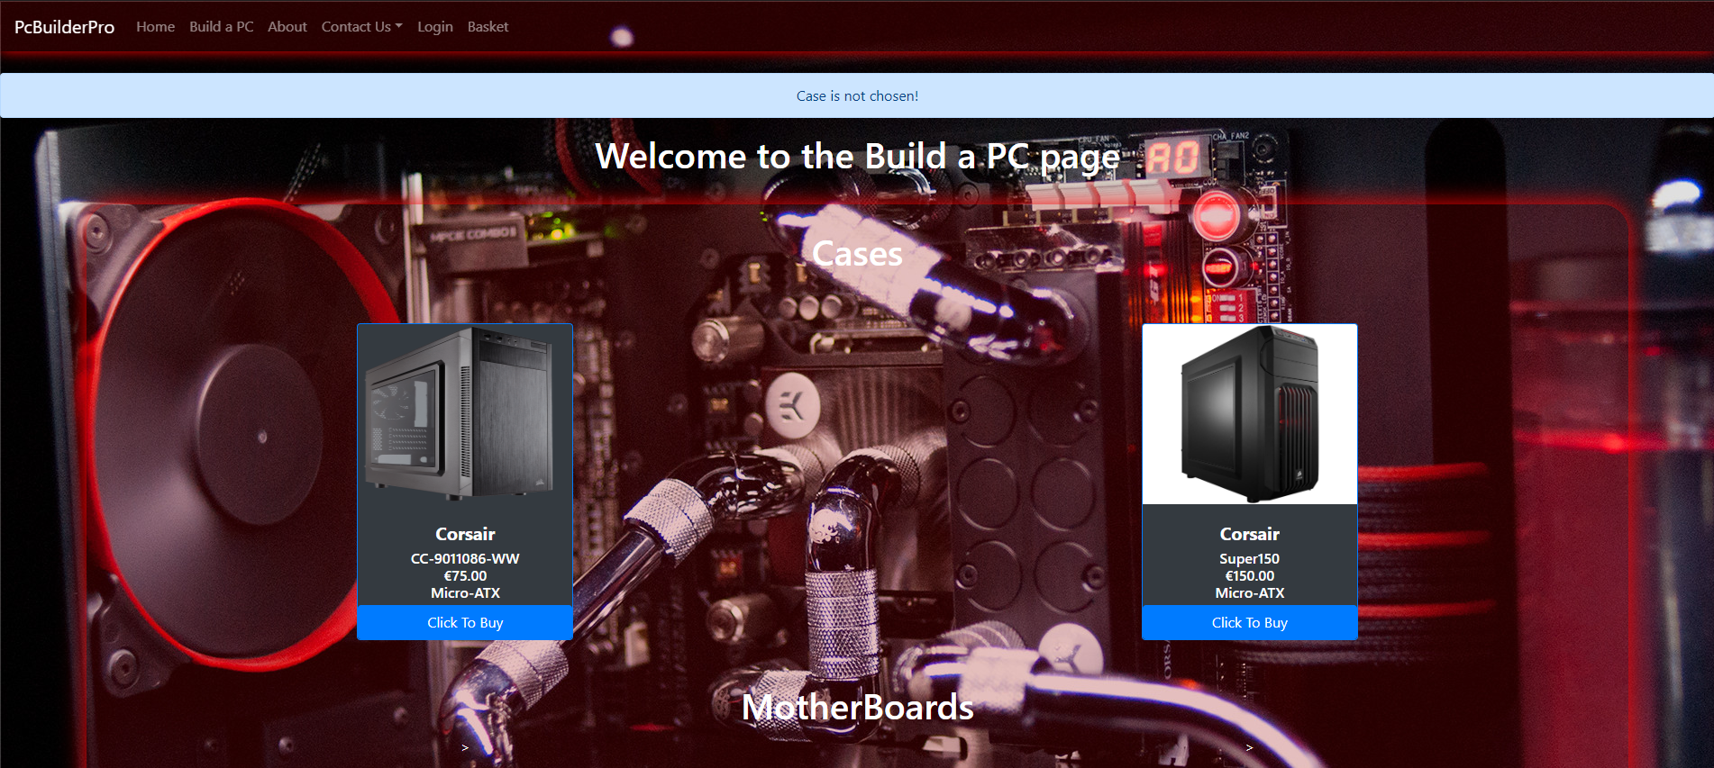

* Our About Page has information regarding us and has also a button which directs the user to the our individual GitHub accounts.

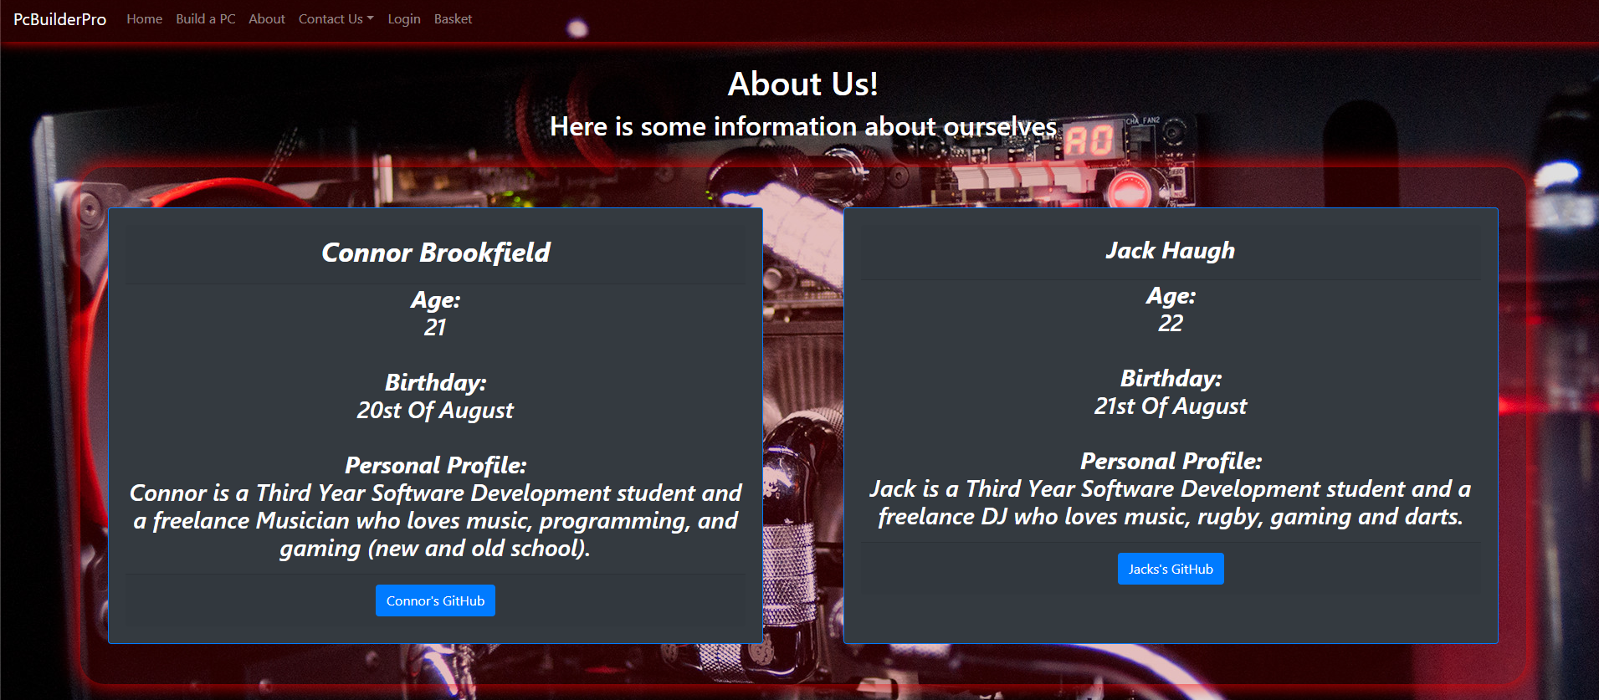

* Our Contact Us page has a dropdown page that has a Query Page and Forum page. The Query page lets the user send info to a server and the forum Page receives any info sent to it

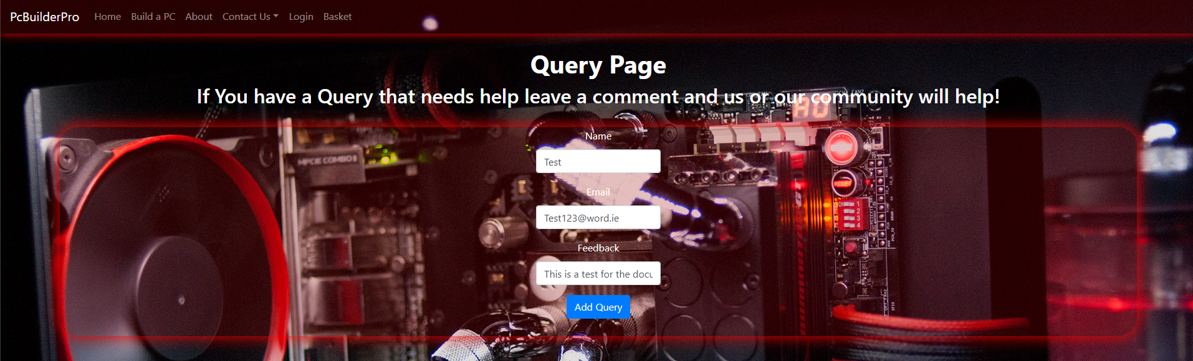

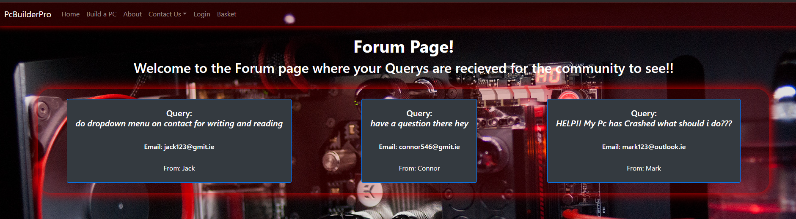

* Our Basket has the components added when you add to basket from build a pc page. If user removes item from basket they go back to build a pc page and add component they are missing.

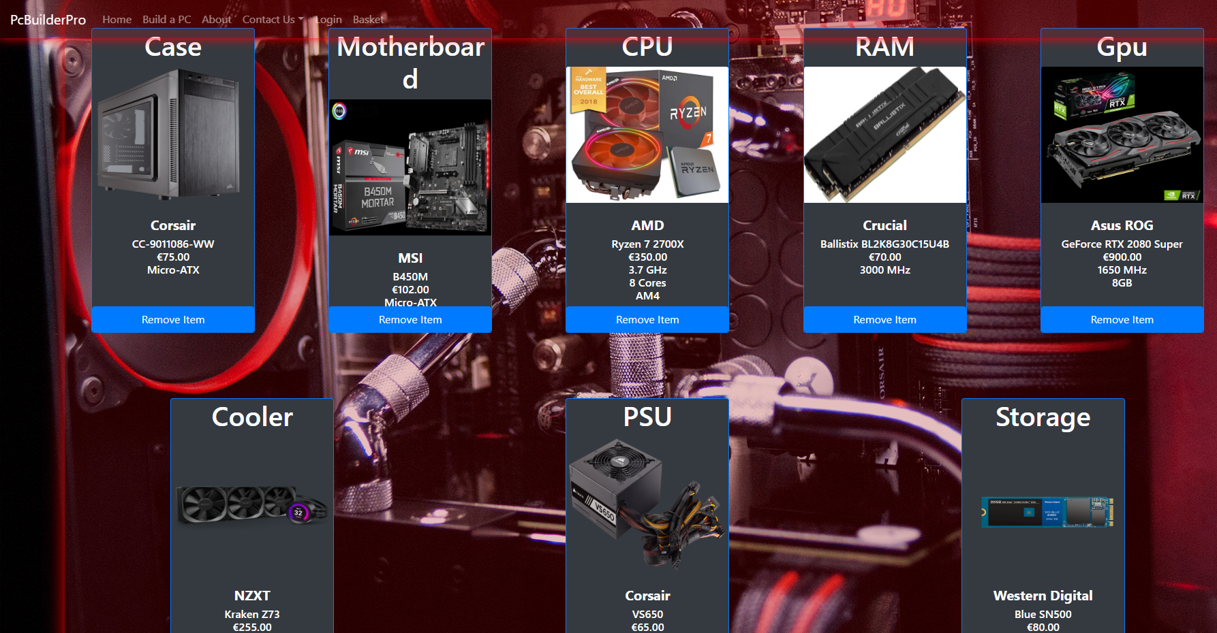

* Our login page has the user to login with a specific email and password and when they are correct they can add components to the build a pc page.

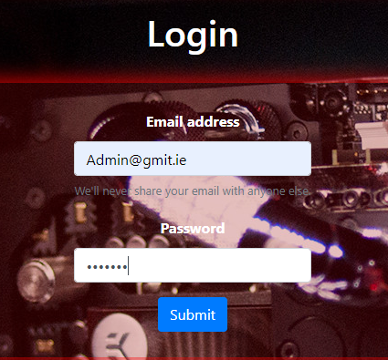

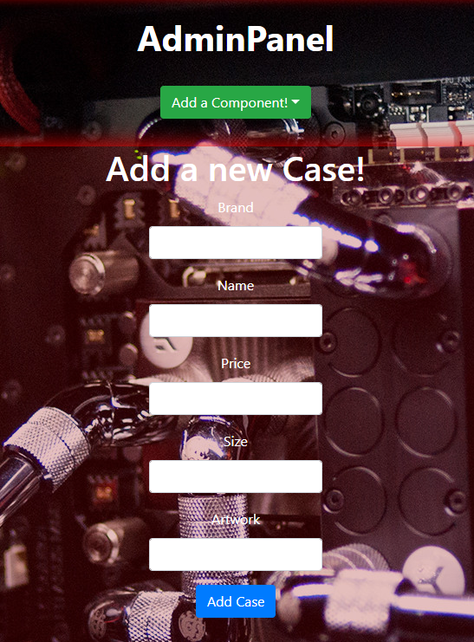

## Testing

* Incremental Testing: we used incremental testing when we were trying to get a block of code working for different pages example when sorting the info being received from the database for the build a pc page.
* Testing the Database: We used this when using the database and adding different types of data to see where the line was.
* Internal Testing: We used this for more of a way to get an insight on the app and testing the different components.
* Black-box Testing: We used this method to see if we could push the website to the limit to see any faults with different sections and it worked well as we found out different flaws we changed and worked on them.

## Recommendations for the future

* While We were overall happy with the outcome of the project and website there are thing that we would like to do down the line if we ever go back to this project.
  + Functional basket with payment: We could see us doing more with the shopping basket in future and add a payment method such as PayPal API to use as a false payment.
  + We could change the layout of the build a pc page to page by page for the components which allows more components on one page.
  + Login and register authentication api in future with firebase for more commercial and functional

## 

## Conclusion

* Upon reaching the end of this group project we both feel that everything we set out to achieve upon beginning it has been accomplished. All tasks we wanted to do were reached with a login page and basket with components being added with a good MongoDB working as it should for the project.
* We feel we both worked great together as a team and had great communication skills and teamwork skills for when deciding on what to do and telling when work was sent to GitHub to push and pull our work.
* Using MongoDb was a great experience again as I got familiar with how a server based online worked with code you type and how it brings info saved there over to your application.
* How to use a collaborative source control such as GitHub effectively which helped us save our work overtime while keeping progress going.
* How we distributed the work between us both and both happy with the outcome with both of our shift in this project.
* Learning react-bootstrap and JavaScript code made it a challenging but rewarding task and overall happy with the learning outcome of the project for both of us which we could definitely put to use later in life.

## References

* Here are a few references that we used when doing the project.
  + <https://www.mongodb.com> – The application for our server based online. Created by Kevin P. Ryan, Eliot Horowitz & Dwight Merriman.
  + <https://github.com/> - The application we used to send and receive work between both of us. Created by Tom Preston-Werner, Chris Wanstrath, P. J. Hyett & Scott Chacon.
  + <https://www.javascript.com/> - The Coding language used for the project. Created by Brendan Eich.
  + <https://react-bootstrap.github.io/> - This helped with the styling between classes for the project
  + <https://code.visualstudio.com/> - The text editor we used to code our project for this module. Created by Microsoft.
  + <https://github.com/axios/axios> - We used this for requests for and to the api with HTTP.